Remove this page as part of the bid package.

Instructions to include prevailing wages:
Your bid package must include the prevailing wages of your county. You can find the prevailing wages for your area by following these steps:

- Go to this website: https://sam.gov/search
- Under “Select Domain” you want to click “Wage Determinations”
- And select “Construction.”
- You then want to Filter by Vermont, your county, and Construction Type Building.
- Here’s an example for Addison:

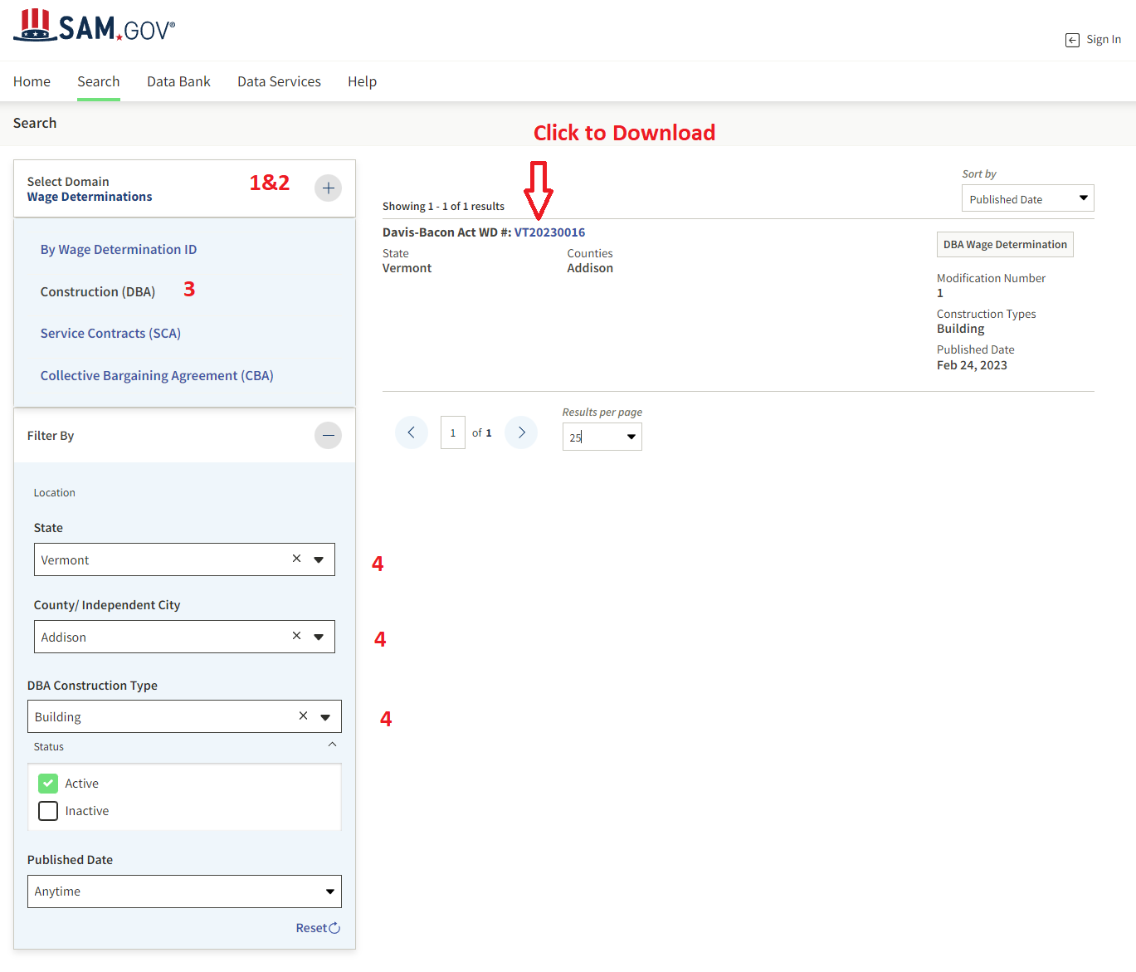

Note: Any bids should be based on this General Contract and the plans and specifications. Further, any bid must be accompanied by a bid bond equal to at least 5% of the contract amount.

GENERAL CONTRACT AGREEMENT

This General Contract Agreement (“Subcontract”) is made this _______ day of____________________, 20 ___ between _____ School District (“District”) and _____________ (“Contractor”). The parties agree as follows:

1. Independent Contractor Status: It is the intention of both parties that Contractor is an independent contractor and not a District agent or employee. Contractor agrees to furnish materials, equipment, tools, and service necessary for the Work described in this Agreement. The Work means the construction and services to produce the results intended by this Agreement, whether completed or partially completed, and includes all labor, materials, equipment, and services to fulfill Contractor’s obligations.

2. Scope of Work: The materials provided, and work performed are specified in the attached Scope of Work. (Exhibit 1) The scope of work shall not be revised, amended or otherwise changed without a written change order from the District. Where additional work is undertaken by Contractor, without prior written approval by the District, Contractor hereby waives any right to payment for such materials or work.

3. Commencement and Substantial Completion of the Work: The Work shall commence on ____ and shall be substantially complete on ____. Substantial completion shall be the time when the Work is substantially complete or sufficiently complete in accordance with this Agreement that the District can legally and reasonably occupy or utilize the Work for its intended use.

3. Warranty of the Work: Contractor guarantees and warrants that materials and equipment furnished under this Agreement will be of good quality and new unless otherwise agreed in writing. Contractor warrants that the work performed under the terms of this Agreement will be free from defects. If there are defects in the work, equipment or materials, Contractor shall promptly remedy and repair any such defects. If Contractor does not promptly remedy any defects, the District may undertake repairs and charge Contractor the reasonable costs of replacement or repair.

4. Design Plans and Specifications: The Contractor shall strictly comply with any and all design plans and specifications provided to it by the District in connection with the materials and work. Failure to comply shall constitute a material breach of this Agreement. Contractor shall be responsible seeking clarification of any questions concerning design plans and specifications.

5. Indemnification: To the fullest extent permissible by law, Contractor shall indemnify and hold harmless the District, it’s officers, employees and agents from and against any and all demands, claims, suits, costs of defense, attorneys’ fees, witness fees, including expert witness fees, liabilities and other expenses including damage to property, loss of use of property or for injury to or death of any person, including, but not limited to, any employee, agent, servant, independent subcontractor or subcontractor of the Contractor, or a member or members of the general public, in any way arising directly or indirectly from or in connection with the construction, installation or other performance of terms of this Agreement by any Contractor.

6. Payment and Waiver of Liens: Contractor shall be paid for the work specified by this Contract pursuant to the attached Schedule of Work and Payments. (Please attach a payment schedule) (Alternatively, you may use this language: Payment Schedule: The District shall make progress payments to Subcontractor within 30 days of approval of the Contractor’s work by the District, less the retainage amount of 10%.) The District may require that all of Contractor’s material suppliers and subcontractors provide waivers of their right to place a lien on the Project in a form satisfactory to the District before payment is made. The District shall not make any payment for materials that have not been delivered to the site.

7. Retainage: Unless otherwise agreed in writing, District shall be entitled to a retainage of (insert percentage) of amounts payable under this Subcontract, which retainage shall not be required to be paid until (Please insert the number of days---also give consideration to whether there is a retainage provision in the General Contract) after the work specified by this Agreement is complete. At that time, the retainage shall be paid only if the work has been satisfactorily performed. The District may offset any financial harm incurred by it because of defective work, if any, from the retainage funds.

8. Assignment of Work/Subcontracting: Subcontractor may not assign or otherwise delegate to independent contractors the work subject to this Agreement without the written consent of The District. The District shall review any subcontract proposed by Contractor before providing consent to subcontract the work. Further, the work specified herein is not assignable and is specific to Contractor. Any assignment of work shall incorporate the provisions of this Agreement such that assignees or subcontractors shall be bound to the District in the same manner and extent as specified for Contractor under this Agreement.

9. Insurance: Contractor shall purchase and provide proof of insurance to the District as specified below. Any subcontractor to Contractor must have and provide proof of insurance to the District for all the insurances identified below.

- Contractor shall maintain at all times during the project a Commercial General Liability Policy for damages from “bodily injury,” property damage,” and “personal and advertising injury” arising out of or caused by any operations and completed operations. Limits of Liability will be $1,000,000.00 each “occurrence,” $2,000,000.00 general aggregate, on a per project basis. Such policy shall also contain a $2,000,000.00 Products Completed Operations Coverage aggregate. The District shall be identified as an additional insured under the policy and the policy shall be primary to any other policies of insurance covering. Any insurance policy and/or coverage purchase by the District shall be excess to Contractor’s coverage, including excess insurance coverage, if any.

b. Completed operations coverage must be maintained for a minimum of two years after the completion of the work specified herein.

- Worker’s Compensation Insurance for all Contractors’ employees, with a minimum Liability Limit of $1,000,000.00.

- Business Auto liability insurance coverage with coverage limits of at least $1,000,000. Such insurance shall provide primary coverage for all of Contractor’s employees and for all motor vehicles utilized in connection with the work performed under this Subcontract. General Contractor and the District shall be named additional insureds under the policy.

- Commercial Umbrella insurance policy with limits equal to or greater than $5,000,000.

The District may at its discretion request proof of insurance at any time during the period in which the policy is required by this Agreement to be effective. If Contractor fails to obtain or maintain the required insurance or to provide proof of insurance, it shall constitute a substantial breach of the Agreement. Without limitation, Contractor shall be liable for any and all costs, liabilities, damages and penalties (including attorney’s fees and costs) resulting to the District from such breach.

10. Builders All-Risk Insurance: The District shall purchase a Builder All Risk insurance policy sufficient to cover any loss to the Work, including losses to property owned or held by Contractor or Contractor’s subcontractors.

11. BONDS: Contractor shall purchase a performance bond for 100 percent of the contract price. A “performance bond” is one executed in connection with a contract to secure fulfillment of all of the contractor’s requirements under such contract. Contractor shall also purchase a payment bond for 100 percent of the contract price. A “payment bond” is one executed in connection with a contract to assure payment as required by law of all persons supplying labor and material in the execution of the work provided in the contract. Contractor shall identify the bonding company for required bonds in bid submissions.

12. EEO Statement: During the performance of this contract, the contractor agrees as follows:
(1) The contractor will not discriminate against any employee or applicant for employment because of race, color, religion, sex, sexual orientation, gender identity, or national origin. The contractor will take affirmative action to ensure that applicants are employed, and that employees are treated during employment, without regard to their race, color, religion, sex, sexual orientation, gender identity, or national origin. Such action shall include, but not be limited to the following: Employment, upgrading, demotion, or transfer, recruitment or recruitment advertising; layoff or termination; rates of pay or other forms of compensation; and selection for training, including apprenticeship. The contractor agrees to post in conspicuous places, available to employees and applicants for employment, notices to be provided by the contracting officer setting forth the provisions of this nondiscrimination clause.
(2) The contractor will, in all solicitations or advertisements for employees placed by or on behalf of the contractor, state that all qualified applicants will receive consideration for employment without regard to race, color, religion, sex, sexual orientation, gender identity, or national origin.
(3) The contractor will not discharge or in any other manner discriminate against any employee or applicant for employment because such employee or applicant has inquired about, discussed, or disclosed the compensation of the employee or applicant or another employee or applicant. This provision shall not apply to instances in which an employee who has access to the compensation information of other employees or applicants as a part of such employee's essential job functions discloses the compensation of such other employees or applicants to individuals who do not otherwise have access to such information, unless such disclosure is in response to a formal complaint or charge, in furtherance of an investigation, proceeding, hearing, or action, including an investigation conducted by the employer, or is consistent with the contractor's legal duty to furnish information.
(4) The contractor will send to each labor union or representative of workers with which it has a collective bargaining agreement or other contract or understanding, a notice to be provided by the agency contracting officer, advising the labor union or workers' representative of the contractor's commitments under section 202 of Executive Order 11246 of September 24, 1965, and shall post copies of the notice in conspicuous places available to employees and applicants for employment.
(5) The contractor will comply with all provisions of Executive Order 11246 of September 24, 1965, and of the rules, regulations, and relevant orders of the Secretary of Labor.
(6) The contractor will furnish all information and reports required by Executive Order 11246 of September 24, 1965, and by the rules, regulations, and orders of the Secretary of Labor, or pursuant thereto, and will permit access to his books, records, and accounts by the contracting agency and the Secretary of Labor for purposes of investigation to ascertain compliance with such rules, regulations, and orders.
(7) In the event of the contractor's non-compliance with the nondiscrimination clauses of this contract or with any of such rules, regulations, or orders, this contract may be canceled, terminated or suspended in whole or in part and the contractor may be declared ineligible for further Government contracts in accordance with procedures authorized in Executive Order 11246 of September 24, 1965, and such other sanctions may be imposed and remedies invoked as provided in Executive Order 11246 of September 24, 1965, or by rule, regulation, or order of the Secretary of Labor, or as otherwise provided by law.
(8) The contractor will include the provisions of paragraphs (1) through (8) in every subcontract or purchase order unless exempted by rules, regulations, or orders of the Secretary of Labor issued pursuant to section 204 of Executive Order 11246 of September 24, 1965, so that such provisions will be binding upon each subcontractor or vendor. The contractor will take such action with respect to any subcontract or purchase order as may be directed by the Secretary of Labor as a means of enforcing such provisions including sanctions for noncompliance: Provided, however, that in the event the contractor becomes involved in, or is threatened with, litigation with a subcontractor or vendor as a result of such direction, the contractor may request the United States to enter into such litigation to protect the interests of the United States.
13. Davis-Bacon Act Compliance: Contractor agrees that it shall pay wages to laborers and mechanics at a rate not less than the prevailing wages specified in a wage determination made by the Secretary of Labor. Contractors shall pay wages not less than weekly. Contractor acknowledges that the prevailing wage information was included in the bid package. Contractor shall familiarize itself with and strictly comply with 40 U.S.C. 3141-3148 in connection with this Agreement. Contractor shall provide District with Department of Labor certified payroll information pursuant to the Act.

14. Anti Kickback Act: The parties shall comply with 40 U.S.C. 3145 as supplemented by the Department of Labor regulations (29 CFR Part 3, Contractors and Subcontractors on Public Building or Public Work Financed in Whole or in Part by Loans or Grants from the United States).

15. Termination by the District for Cause: The District may terminate the Contractor’s right to complete the Work under this Agreement, in whole or in part, if Contractor fails to provide proper supervision or enough properly skilled workers or proper materials, equipment, tools or machinery; fails to make timely payment to Subcontractors or suppliers; disregards or violates any laws or regulations; fails to timely perform the Work; fails to promptly correct rejected or non-conforming Work or remedy property damage for which it is responsible; if Contractor has committed a material breach of this Agreement or if Contractor files for bankruptcy or if a receiver is appointed on account of insolvency.

16. Suspension by the District for Convenience: The District may without cause order the Contractor in writing to suspend or interrupt the Work in whole or in part for such period of time as the District determines.

17. Termination by the District for Convenience: The District may at any time terminate ethe Contractor’s right to complete the Work under this Agreement for the Owner’s convenience and without cause. Upon written notice, the Contractor shall cease operations, take actions necessary or as directed by the District for protection of the Work and terminate all existing subcontracts and purchase orders. In the case of such termination, the Contractor shall be entitled to receive payment for Work completed and direct costs incurred by reason of such termination, but not costs, overhead or profit on the Work not completed or any other damages that might be alleged by the Contractor.

18. Safety of Persons and Property: The Contractor shall take reasonable safety precautions for the safety of, and shall provide reasonable protection to prevent damage, injury or loss to, employees on the Work or other persons who could be affected thereby, the Work, materials and equipment located at the Project site. The Contractor shall comply with all state, federal and municipal safety laws, rules or regulations in connection with the Work. Contractor shall designate a responsible member of the Contractor’s organization at the Project site whose duty shall be the prevention of accidents.

19. Clean Air Act and Federal Water Pollution Control Act: The Contractor shall comply with all applicable provisions of the Clean Air Act (42 U.S.C. 7401-7671q) and the Federal Water Pollution Control Act (33 U.S.C. 1251-1387). It will report any violations to Owner and the Regional Office of the Environmental Protection Agency.

20. Liquidated damages: It is acknowledged that the Contractor’s failure to achieve substantial completion of the Work within the Contract Time provided by the Contract Documents will cause the Owner to incur substantial economic damages and losses of types and in amounts which are impossible to compute and ascertain with certainty as a basis for recovery by the Owner of actual damages, and that liquidated damages represent a fair, reasonable and appropriate estimate thereof. Accordingly, in lieu of actual damages for such delay, the Contractor agrees that liquidated damages may be assessed and recovered by the Owner as against Contractor and its Surety, in the event of delayed completion and without the Owner being required to present any evidence of the amount or character of actual damages sustained by reason thereof; therefore Contractor shall be liable to the Owner for payment of liquidated damages in the amount of One Thousand Dollars ($1,000) for each day that Substantial Completion is delayed beyond the Contract Time as adjusted for time extensions provided by the Contract Documents. Such liquidated damages

21. Eligibility for Federal Work: Contractor represents and warrants that it is not listed on the government wide exclusions in the System for Award management. Contractor shall certify eligibility at time of bid.

22. Anti-Lobbying: Contractor shall provide to Owner a certification and shall obtain from any subcontractors on the Project a certification to be submitted to the Owner that it is in compliance with the Byrd Anti-Lobbying Amendment (31 U.S.C. 1352).

23. Contract Work Hours and Payroll: Contract shall comply with the Fair Labor Standards Act, including payment of overtime on for any work in excess of 40 hours per week. All employees shall be paid at least weekly.

24. The District’s and Contractor’s Obligations upon Default: In the event Contractor terminates this Agreement because of a breach of the terms of this Agreement or in the event that the District terminates this Agreement, the District shall have no liability to Contractor except to pay the contract price for work satisfactorily completed. Contractor hereby waives and releases any rights or claims for consequential damages arising from or related to its performance under the terms of this Agreement or termination of the Agreement. Contractor shall be liable for, without limitation, any extra costs incurred to obtain substitute performance to complete the work, including design, managerial, administrative and materials costs. The District shall be entitled to its attorney’s fees and costs in connection with any claims, damages or demands for compensation made by it against Contractor where the Contractor has breached the terms or conditions of this Agreement.

25. Waiver of Subrogation: Contractor and its insurers hereby waive any and all rights of subrogation against the District, its officers, directors, employees, agents, representatives and insurers for any claims arising from or related to the work performed hereunder or harm suffered by Contractor in connection with this project. All insurances purchased pursuant to this Agreement shall contain a waiver of subrogation provision or endorsement in the policy.

26. Governing Law: This Subcontract shall be governed by and construed under the laws of the State of Vermont. Any litigation relating to or arising from this Subcontract shall be initiated and maintained in the State of Vermont and Vermont shall have exclusive jurisdiction over any such disputes. The District shall be entitled to attorneys’ fees and costs if it is a substantially prevailing party in connection with any claim or suit arising from or related to this Agreement.

27. Mediation and Arbitration: The parties agree that any disputes, claims or disagreements arising from or related to this Subcontract or the work performed pursuant to the Subcontract shall be first submitted to mediation at a mutually agreeable Vermont location with an impartial mediator. In the event that the matter is not resolved at mediation, the parties hereby agree that the matter will be submitted to binding arbitration. The arbitration shall be subject to and governed by the procedures and requirements of the Vermont Arbitration Act.

28. Domestic Preference for Procurement
Contractor will, to the greatest extent practicable, provide a preference for the purchase, acquisition, or use of goods, products, or materials produced in the United States (including but not limited to iron, aluminum, steel, cement, and other manufactured products). Contractor will include this requirement in any subcontract contractor executes in connection with this project.
For purposes of this section:
“Produced in the United States” means, for iron and steel products, that all manufacturing processes, from the initial melting stage through the application of coatings, occurred in the United States.
“Manufactured products” means items and construction materials composed in whole or in part of non-ferrous metals such as aluminum; plastics and polymer-based products such as polyvinyl chloride pipe; aggregates such as concrete; glass, including optical fiber; and lumber.

29. Procurement of Recovered Materials
Contractor shall use only products, as designated in EPA guidelines, which contain the highest practical percentage of recovered materials unless the product cannot be acquired:

- Competitively within a timeframe providing for compliance with the contract performance schedule;
- Meeting contract performance requirements; or
At a reasonable price.

ACKNOWLEDGEMENT OF ARBITRATION:

I understand that this agreement contains an agreement to arbitrate. After signing this document, I understand that I will not be able to bring a lawsuit concerning any dispute that may arise which is covered by this arbitration agreement, unless it involves a question of constitutional or civil rights. Instead, I agree to submit any such dispute to an impartial arbitrator.

28. Severability: In the event any provision of this Contract shall be declared invalid, such provision shall be deemed severable from the remaining provisions of this Agreement, which shall remain in full force and effect.

29. Waiver of Consequential Damages: Contractor hereby for itself and any assignees or subcontractors waives the right to seek consequential damages against the District. Any claims raised by Contractor shall be limited to amounts owed as payment for work performed under this Agreement.

30. Notices: All written notices shall be sent to the parties by U.S. mail at the following locations:

Signed, this ___ day of ________, 20____.

Contractor:

By:__________________________________
Authorized Representative

Signed, this ___ day of _______, 20__

The District

By:________________________________________
Authorized Representative

